**PARTA:** **IMPLEMENTED USING CONCEPT OF STALLING**

**MINI PROJECT 2**

IMPLEMENTATION OF 5 STAGED PIPELINED OF MIPS ISA OVERCOMING DATA HAZARDS

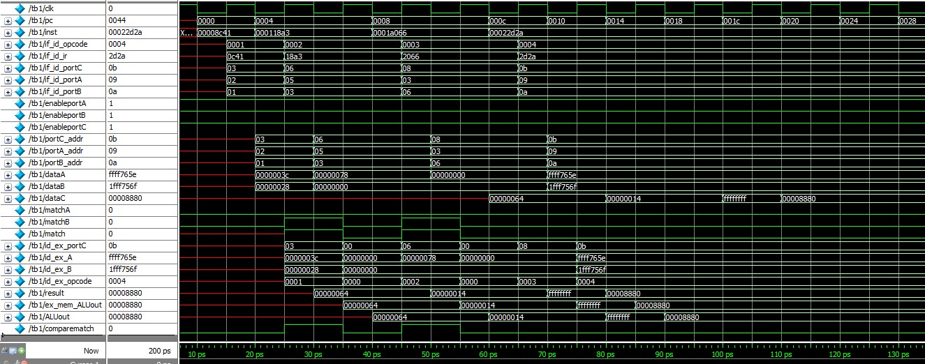

**SIMULATION**

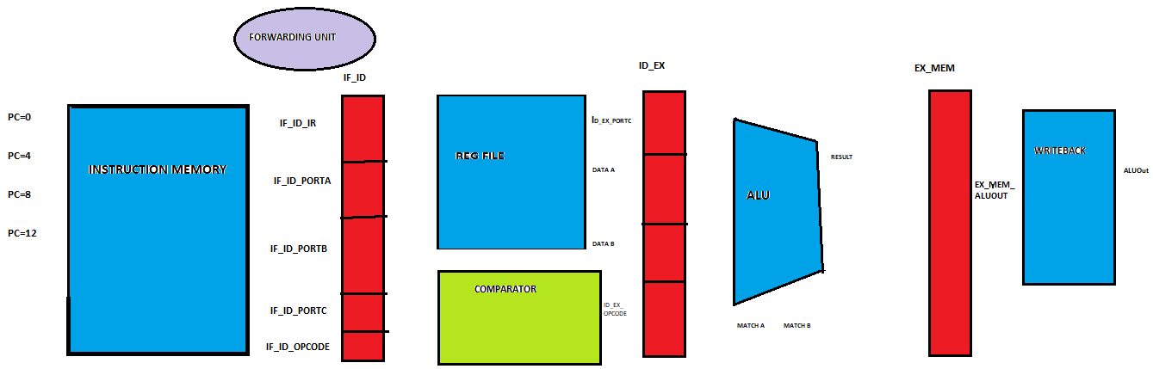

**ARCHITECTURE**

**PARTB: IMPLEMENTED USING CONCEPT OF DATA FORWARDING**

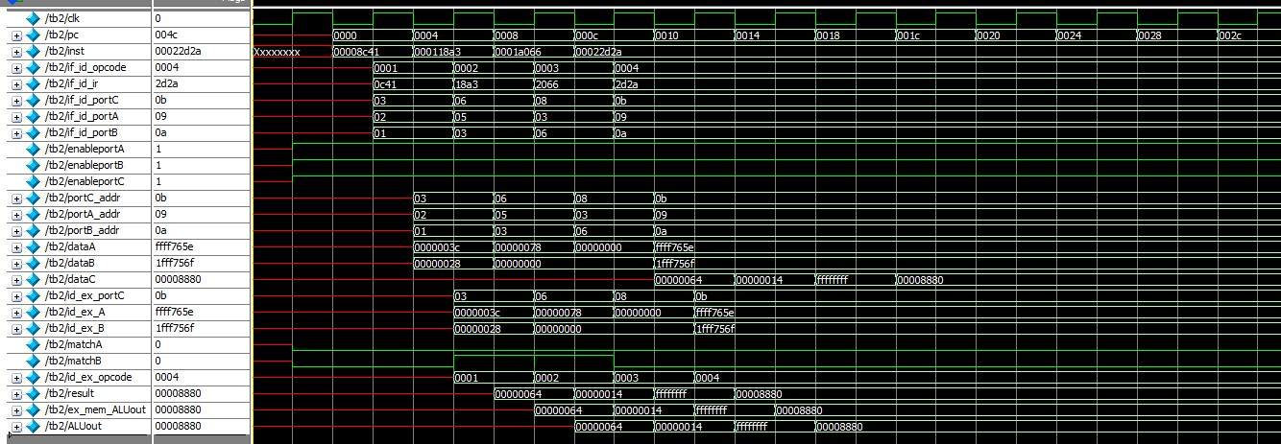

**SIMULATION**

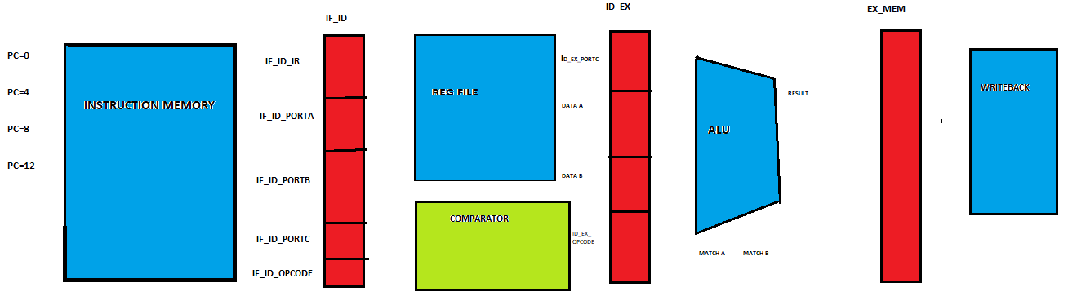**ARCHITECTURE**

**Sheet for uploading**

Fill the following table:

To detect data hazard using data forwarding and data stalling.

|  |  |  |
| --- | --- | --- |
| Memory | Instructions | Register status (Show the registers which are |
| Address |  | only affected). Remarks on hazards and what |
|  |  | is the solution? |
|  |  | ( ) 🡪 represents Decimal |
| 0000 | ADD R3 , R2, R1 | R2 = 3C (60) , R1= 28 (40) |
|  |  | R3 = 64 ( 100 )  First instruction doesn’t have any data hazard. |
| 0004 | SUB R6 , R5 ,R3 | R5 = 78 (120) , R3 = 0(0) [Initially stored as 0 in the register file and later overwritten by the previous inst. Destination register) , |
|  |  | R6 = 14 (20)  RAW hazard found at R3 register with respect to first instruction. |
| 0008 | NAND R8 ,R3 , R6 | R3 =0 , R6 =0 (Initially)  Overwritten as R3 = 64(100) , R6 = 14(20)  RAW hazard found at R6 register and R3 register with respect to second instruction. |
|  |  | R8 = 0xFFFFFFFF. |
| 000C | NOR R11 , R9 , R10 | R9 = 0xFFFF765E , R10 = 0x1FFF756F ,  No data hazard found destination register  R11 = 0x0008880. |
|  |  |  |

**Honor Code Declaration by student:**

* My answers to the above questions are my own work.
* I have not shared the codes/answers written by me with any other students. (I might have helped clear doubts of other students).
* I have not copied other’s code/answers to improve my results. (I might have got some doubts cleared from other students).

**Name: VARUN KUMAR S** **Date: 25/05/2020**

**ID No.: 2019H1400539G**